# VISVESVARAYA TECHNOLOGICAL UNIVERSITY

## BELAGAVI – 590018, Karnataka INTERNSHIP REPORT

#### ON

“Interactive Data Journalism Page”

***Submitted in partial fulfilment for the award of degree(21CSI85)***

## BACHELOR OF ENGINEERING IN

## INFORMATION SCIENCE & ENGINEERING

***Submitted by:***

#### VARSHITHA.P.N

#### 1DB22IS422



Conducted at

**VARCONS TECHNOLOGIES Pvt Ltd**



# DON BOSCO INSTITUTE OF TECHNOLOGY

**Department of Information Science & Engineering**

**Accredited by NBA, New Delhi**

# Kumbalagodu Bengaluru Karnataka 560074

# DON BOSCO INSTITUTE OF TECHNOLOGY

**Department of Information Science & Engineering**

**Accredited by NBA, New Delhi**

# Kumbalagodu Bengaluru Karnataka 560074

# 

**CERTIFICATE**

This is to certify that the Internship titled **“Interactive Data Journalism Page”** carried out by **Mrs. VARSHITHA P N,** a bona fide student of Don Bosco Institute of Technology, in partial fulfillment for the award of **Bachelor of Engineering**, in **INFORMATION SCIENCE & ENGINEERING** under Visvesvaraya Technological University, Belagavi, during the year 2023-2024. It is certified that all corrections/suggestions indicated have been incorporated in the report.

The project report has been approved as it satisfies the academic requirements in respect of Internship prescribed for the course Internship / Professional Practice (21INT68)

#### Signature of Guide Signature of HOD Signature of Principal

**External Viva:**

Name of the Examiner Signature with Date

1)

2)

# D E C L A R A T I O N

I, **VARSHITHA P N**, v semester student of Information Science & Engineering, Don Bosco Institute of Technology - 560074, declare that the Internship has been successfully completed, in **VARCONS TECHNOLOGY**. This report is submitted in partial fulfillment of the requirements for award of Bachelor Degree in Branch name, during the academic year 2023-2024.

Date:03/12/2023

Place: Bangalore

USN :1DB22IS422

NAME: VARSHITHA P N

**OFFER LETTER PROVIDED BY THE COMPANY**

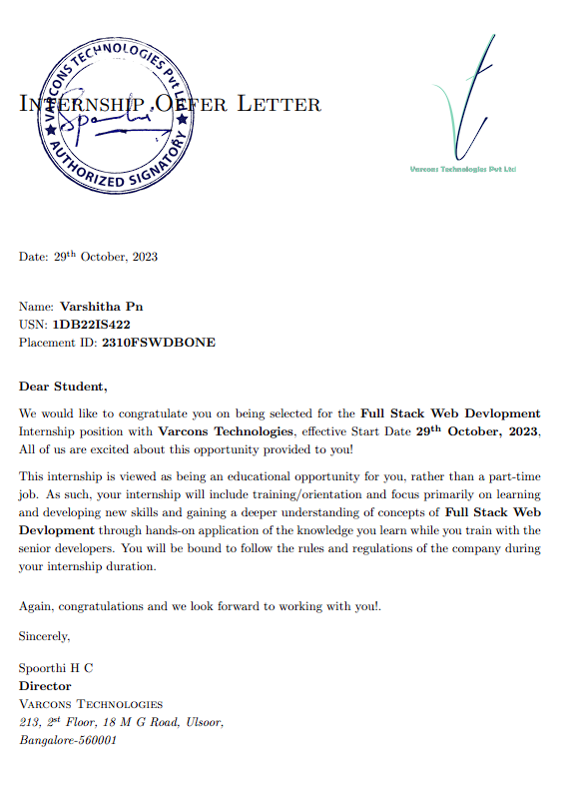

# A C K N O W L E D G E M E N T

This Internship is a result of accumulated guidance, direction and support of several important persons. We take this opportunity to express our gratitude to all who have helped us to complete the Internship.

We express our sincere thanks to our Principal **Dr. B.S Naghabhushana,** Don BoscoInstitute of Technology, for providing us adequate facilities to undertake this Internship.

We would like to thank our **Dr.B.K Raghavendra** Head of Dept – Information Science & Engineering, for providing us an opportunity to carry out Internship and for his valuable guidance and support.

We express our deep and profound gratitude to our guide, **Mrs.R YASHODARA**, Assistant/Associate Prof, for her keen interest and encouragement at every step in completing the Internship.

We would like to thank all the faculty members of our department for the support extended during the course of Internship.

We would like to thank the non-teaching members of our dept, for helping us during the Internship.

Last but not the least, we would like to thank our parents and friends without whose constant help, the completion of Internship would have not been possible.

**VARSHITHA P N**

**1DB22IS422**

# ABSTRACT

Overview of website development is the skill of creating presentation of content (usually hypertext or hypermedia) that is delivered to world wide web, using web browser or other web enabled software. The intent of website development is to create a website- a collection of document and applications that resides on the web server/servers. The website may include text, images, sounds and other contents and may be interactive.

With growing specialization in information technology field, there a strong distinguish between web design and web development. Web designers create a website’s look and feel, and web developers create the code to make it work. The process of designing web pages, web sites, web application or multimedia for web may utilize multiple disciplines such as animation, designing interaction design, photography. Web pages and websites can be state pages or can be programmed to be dynamic pages that automatically adopt content or visual appearance depending on variety of factors, such as input form from end -user, input the webmaster. Accessible web design however permits an exception where tables for layout either linearized or alternate version is made available that allow changes to be made to Webpages without the need of obtaining web-based programming language.

Very important several different components of web development and interaction can work together in order for the web to be accessible to people with disabilities. Components includes

Web browser, media players and other user’s agents, User knowledge, experiences, strategies using web.

Developers-designers, codes, author etc including with disabilities and users who contribute contents.

Evaluation tools- web accessibility evaluation tools, HTML validators, CSS validators, etc.

# Table of Contents

|  |  |  |
| --- | --- | --- |
| **Sl no** | **Description** | **Page no** |
| 1 | Company Profile | 8-9 |
| 2 | About the Company | 10-13 |
| [3](https://1.bp.blogspot.com/-dODuK8N5h1Q/Wlnyb3V9HFI/AAAAAAAACL4/WxQtCJ1pM5wccDABg4wIrTBUB0vlikXQQCLcBGAs/s1600/poly1.jpg) | Introduction | 14-16 |
| [4](https://1.bp.blogspot.com/-dODuK8N5h1Q/Wlnyb3V9HFI/AAAAAAAACL4/WxQtCJ1pM5wccDABg4wIrTBUB0vlikXQQCLcBGAs/s1600/poly1.jpg) | System Analysis | 17-18 |
| [5](https://1.bp.blogspot.com/-dODuK8N5h1Q/Wlnyb3V9HFI/AAAAAAAACL4/WxQtCJ1pM5wccDABg4wIrTBUB0vlikXQQCLcBGAs/s1600/poly1.jpg) | Requirement Analysis | 19-20 |
| 6 | Design [Analysis](https://4.bp.blogspot.com/-IOOxgPaXMVc/Wlj3LWvcnjI/AAAAAAAACKE/UeTFYvAxDmUDel5UBjdifeWaApB3-dXVgCLcBGAs/s1600/img1.jpg) | 21-22 |
| 7 | [Implementation](https://4.bp.blogspot.com/-IOOxgPaXMVc/Wlj3LWvcnjI/AAAAAAAACKE/UeTFYvAxDmUDel5UBjdifeWaApB3-dXVgCLcBGAs/s1600/img1.jpg) | 23-24 |
| 8 | Snapshots | 25-27 |
| 9 | Conclusion | 28-29 |
| 10 | References | 30 |

[**CHAPTER**](https://1.bp.blogspot.com/-dODuK8N5h1Q/Wlnyb3V9HFI/AAAAAAAACL4/WxQtCJ1pM5wccDABg4wIrTBUB0vlikXQQCLcBGAs/s1600/poly1.jpg) **1** **COMPANY PROFILE**

# COMPANY PROFILE

## A Brief History of Company

**Varcons Technologies Pvt Ltd**, was incorporated with a goal “To provide high quality and optimal Technological Solutions to business requirements of our clients”. Every business is a different and has a unique business model and so are the technological requirements. They understand this and hence the solutions provided to these requirements are different as well. They focus on clients requirements and provide them with tailor made technological solutions. They also understand that Reach of their Product to its targeted market or the automation of the existing process into e-client and simple process are the key features that our clients desire from Technological Solution they are looking for and these are the features that we focus on while designing the solutions for their clients.

Sarvamoola Software Services. is a Technology Organization providing solutions for all web design and development, MYSQL, PYTHON Programming, HTML, CSS, ASP.NET and LINQ. Meeting the ever increasing automation requirements, Sarvamoola Software Services. specialize in ERP, Connectivity, SEO Services, Conference Management, effective web promotion and tailor-made software products, designing solutions best suiting clients requirements.

Company, strive to be the front runner in creativity and innovation in software development through their well-researched expertise and establish it as an out of the box software development company in Bangalore, India. As a software development company, they translate this software development expertise into value for their customers through their professional solutions.

They understand that the best desired output can be achieved only by understanding the clients demand better. Company work with their clients and help them to defiine their exact solution requirement. Sometimes even they wonder that they have completely redefined their solution or new application requirement during the brainstorming session, and here they position themselves as an IT solutions consulting group comprising of high caliber consultants.

They believe that Technology when used properly can help any business to scale and achieve new heights of success. It helps Improve its efficiency, profitability, reliability; to put it in one sentence “Technology helps you to Delight your Customers” and that is what we want to achieve.

# [CHAPTER](https://1.bp.blogspot.com/-dODuK8N5h1Q/Wlnyb3V9HFI/AAAAAAAACL4/WxQtCJ1pM5wccDABg4wIrTBUB0vlikXQQCLcBGAs/s1600/poly1.jpg) 2 ABOUT THE COMPANY

1. **ABOUT THE COMPANY**

Company is a Technology Organization providing solutions for all web design and development, MYSQL, PYTHON Programming, HTML, CSS, ASP.NET and LINQ. Meeting the ever increasing automation requirements, Company specialize in ERP, Connectivity, SEO Services, Conference Management, effective web promotion and tailor-made software products, designing solutions best suiting clients requirements. The organization where they have a right mix of professionals as a stakeholders to help us serve our clients with best of our capability and with at par industry standards. They have young, enthusiastic, passionate and creative Professionals to develop technological innovations in the field of Mobile technologies, Web applications as well as Business and Enterprise solution. Motto of our organization is to “Collaborate with our clients to provide them with best Technological solution hence creating Good Present and Better Future for our client which will bring a cascading a positive effect in their business shape as well”. Providing a Complete suite of technical solutions is not just our tag line, it is Our Vision for Our Clients and for Us, We strive hard to achieve it.

## Products of Company.

**Android Apps**

It is the process by which new applications are created for devices running the Android operating system. Applications are usually developed in Java (and/or Kotlin; or other such option) programming language using the Android software development kit (SDK), but other development environments are also available, some such as Kotlin support the exact same Android APIs (and bytecode), while others such as Go have restricted API access.

The Android software development kit includes a comprehensive set of development tools. These include a debugger, libraries, a handset emulator based on QEMU, documentation, sample code, and zutorials. Currently supported development platforms include computers running Linux (any modern desktop Linux distribution), Mac OS X 10.5.8 or later, and Windows 7 or later. As of March 2015, the SDK is not available on Android itself, but software development is possible by using specialized Android applications.

**Web Application**

It is a client–server computer program in which the client (including the user interface and client- side logic) runs in a web browser. Common web applications include web mail, online

retail sales, online auctions, wikis, instant messaging services and many other functions. web applications use web documents written in a standard format such as HTML and JavaScript, which are supported by a variety of web browsers. Web applications can be considered as a specific variant of client–server software where the client software is downloaded to the client machine when visiting the relevant web page, using standard procedures such as HTTP. The Client web software updates may happen each time the web page is visited. During the session, the web browser interprets and displays the pages, and acts as the universal client for any web application. The use of web application frameworks can often reduce the number of errors in a program, both by making the code simpler, and by allowing one team to concentrate on the framework while another focuses on a specifified use case. In applications which are exposed to constant hacking attempts on the Internet, security- related problems can be caused by errors in the program.

Frameworks can also promote the use of best practices such as GET after POST. There are some who view a web application as a two-tier architecture. This can be a “smart” client that performs all the work and queries a “dumb” server, or a “dumb” client that relies on a “smart” server. The client would handle the presentation tier, the server would have the database (storage tier), and the business logic (application tier) would be on one of them or on both. While this increases the scalability of the applications and separates the display and the database, it still doesn’t allow for true specialization of layers, so most applications will outgrow this model. An emerging strategy for application software companies is to provide web access to software previously distributed as local applications. Depending on the type of application, it may require the development of an entirely different browser-based interface, or merely adapting an existing application to use different presentation technology. These programs allow the user to pay a monthly or yearly fee for use of a software application without having to install it on a local hard drive. A company which follows this strategy is known as an application service provider (ASP), and ASPs are currently receiving much attention in the software industry.

Security breaches on these kinds of applications are a major concern because it can involve both enterprise information and private customer data. Protecting these assets is an important part of any web application and there are some key operational areas that must be included in the development process. This includes processes for authentication, authorization, asset handling, input, and logging and auditing. Building security into the applications from the beginning can be more effective and less disruptive in the long run.

**Web design**

It is encompasses many different skills and disciplines in the production and maintenance of websites. The different areas of web design include web graphic design; interface design; authoring, including standardized code and proprietary software; user experience design; and

search engine optimization. The term web design is normally used to describe the design process relating to the front-end (client side) design of a website including writing mark up. Web design partially overlaps web engineering in the broader scope of web development. Web designers are expected to have an awareness of usability and if their role involves creating mark up then they are also expected to be up to date with web accessibility guidelines. Web design partially overlaps web engineering in the broader scope of web development.

## Departments and services offered

Company plays an essential role as an institute, the level of education, development of student’s skills are based on their trainers. If you do not have a good mentor then you may lag in many things from others and that is why we at Company gives you the facility of skilled employees so that you do not feel unsecured about the academics. Personality development and academic status are some of those things which lie on mentor’s hands. If you are trained well then you can do well in your future and knowing its importance of Company always tries to give you the best.

They have a great team of skilled mentors who are always ready to direct their trainees in the best possible way they can and to ensure the skills of mentors we held many skill development programs as well so that each and every mentor can develop their own skills with the demands of the companies so that they can prepare a complete packaged trainee.

## Services provided by Company.

* Core Java and Advanced Java
* Web services and development
* Dot Net Framework
* Python
* Selenium Testing
* Conference / Event Management Service
* Academic Project Guidance
* On The Job Training
* Software Training

# [CHAPTER](https://1.bp.blogspot.com/-dODuK8N5h1Q/Wlnyb3V9HFI/AAAAAAAACL4/WxQtCJ1pM5wccDABg4wIrTBUB0vlikXQQCLcBGAs/s1600/poly1.jpg) 3 INTRODUCTION

1. **INTRODUCTION**

## Introduction to Web Apps

Web applications are similar to the traditional applications you’d install on your Information, such as Microsoft Office. They are able to perform the same kinds of tasks, they look the same and they feel the same but there is one key difference - the application itself is not installed on your phone or Information, but lives in the cloud. Web apps are not new, but it used to be that they were often unable to compete with more traditional applications for business critical functions or where rich user interaction was required. This is no longer the case. With the power of modern web technologies, we are able to design and build performing, secure, and feature rich applications that live in the cloud and bring with them a huge number of benefits.

#### They can be accessed from anywhere.

* Because web applications are built with web technologies and they run in a web browser Internet Explorer, Google Chrome, Mozilla Firefox – this allows them to be accessed from every web enabled tool. As long as you have an internet connection you can use them.
* It allows for remote working, it allows for rapid publishing of content, it allows for real time collaboration between teams. If you have web access, you have the ability to access your business tools.

#### They are cost effective.

* Web applications are cheaper to produce and maintain than traditional applications. No matter how many platforms your business uses (Mac, Linux, Windows) web application build can be used across them all.

#### They benefit from more rapid update cycles.

* A huge benefit of web applications is that when an update is released, all of your users are immediately using that version. This doesn’t happen with installed applications, especially in large organizations with IT policies that restrict administrator access.

#### They are secure.

* Web developers have had to become experts in security – the web is a platform designed to share everything with everyone! As such, the types and levels of security included in web applications are often far greater than those seen in traditional applications.
* They also benefit from the ability to launch updates in real-time – the application on the servers is the application people are using. The applications on people’s laptops however is the version last installed. And when those laptops get left on a train it’s not a concern, as nothing is stored locally.

#### They enable more computing with fewer Information.

* Web applications push all of the hard work to the servers, and act as intermediaries between the user interface and the calculations happening behind the scenes. This means you can accomplish terrifyingly complex work on a tablet, or your phone.
* We’ve built web applications that allow people to understand the complex relationships between 250,000 pieces of art on their phones, and applications that run the business systems of one of the largest solar energy providers in the world. Often these products are not financially viable to build using traditional application processes.

## Problem Statement

Develop an application which facilitates creation of web pages having a need to install any HTML editor based software and also which can be used by any novice user (no HTML knowledge needed) that is developing web pages on the online. This module is designed to reduce the process involved in managing the activity of customers and business where the business can sell their services and the customers can buy those.

## Introduction to B2C Ecommerce Website Development with Admin Panel

B2C E-commerce website content providers to focus on creating effective assessment questions and focusing on providing a platform for easy access between Buyer and Consumer.

Here we present techniques that are pertinent to the elements of assessment process: answers submission, Informationized grading, and feedback after submission. As the modern organizations are automated and Informations are working as per the instructions, it becomes essential for the coordination of human beings, commodity and Informations in a modern

organization.

# [CHAPTER](https://1.bp.blogspot.com/-dODuK8N5h1Q/Wlnyb3V9HFI/AAAAAAAACL4/WxQtCJ1pM5wccDABg4wIrTBUB0vlikXQQCLcBGAs/s1600/poly1.jpg) 4 SYSTEM ANALYSIS

**4. SYSTEM ANALYSIS**

## Existing System

Existing System Software means the "System Software" under and as defined in the System Agreement, which includes the "Application Software" and "Operating Software", in each case, under and as defined in the System Agreement and itemized in Exhibit B (Schedule of Prices and Payments). References to Existing System Software may include one or more Components or modules thereof or all Existing System Software in the System.

## Proposed System

Proposed System means the assembly of an operational group of computer programs that will perform, without modification, a significant portion of the functional requirements contained in this RFP. The Proposed System should include system interfaces and conversion tools as well as Contractor supplied or recommended third party software products required to properly design, develop, test, train, implement, interface, tune, and operate the Proposed Solution. The Proposed System should include Document Management, Workflow, a Rules Engine, and Customer Relationship Management functionality.

## Objective of the System

In computer science, an object can be a variable, a data structure, a function, or a method. As regions of memory, objects contain a value and are referenced by identifiers.

In the object-oriented programming paradigm, an object can be a combination of variables, functions, and data structures; in particular in class-based variations of the paradigm, an object refers to a particular instance of a class.

In the relational model of database management, an object can be a table or column, or an association between data and a database entity (such as relating a person's age to a specific person).

A standard method to package distributed objects is via an Interface Definition Language (IDL). An IDL shields the client of all of the details of the distributed server object. Details such as which computer the object resides on, what programming language it uses, what operating system, and other platform-specific issues. The IDL is also usually part of a distributed environment that provides services such as transactions and persistence to all objects in a uniform manner. Two of the most popular standards for distributed objects are the Object Management Group's CORBA standard and Microsoft's DCOM.

# [CHAPTER](https://1.bp.blogspot.com/-dODuK8N5h1Q/Wlnyb3V9HFI/AAAAAAAACL4/WxQtCJ1pM5wccDABg4wIrTBUB0vlikXQQCLcBGAs/s1600/poly1.jpg) 5 REQUIREMENT ANALYSIS

**5. REQUIREMENT ANALYSIS**

## Hardware Requirement Specification

* + MySQL
  + NODE JS
  + Notepad++ Editor
  + Processor: Intel core i5 processer
  + Memory: 15.6 GB
  + Hard Disk: 40 GB

## Software Requirement Specification

### Functional Requirements

* + Operating System :- Windows/64-bit Microsoft
  + Language Used : - HTML, CSS, JAVASCRIPT.
  + IDE Used :- VS code

### Non-Functional Requirements

#### Availability

The online registration system shall permit backing up of the registration database while other registration actives are going on.

#### Accessibility

The system shall be accessible by people with specific vision needs to the extent that a user shall be able to display whole user interface in a larger font without truncating displayed text or other values.

#### Security

The access permissions for system data may only be change by the systems data administrator passwords shall never be viewable at the point of entry or any other time.

# [CHAPTER](https://1.bp.blogspot.com/-dODuK8N5h1Q/Wlnyb3V9HFI/AAAAAAAACL4/WxQtCJ1pM5wccDABg4wIrTBUB0vlikXQQCLcBGAs/s1600/poly1.jpg) 6 DESIGN ANALYSIS

1. **DESIGN & ANALYSIS**

Object-oriented analysis and design (OOAD) is a technical approach for analyzing and designing an application, system, or business by applying object-oriented programming, as well as using visual modeling throughout the software development process to guide stakeholder communication and product quality.

OOAD in modern software engineering is typically conducted in an iterative and incremental way. The outputs of OOAD activities are analysis models (for OOA) and design models (for OOD) respectively. The intention is for these to be continuously refined and evolved, driven by key factors like risks and business value.

The purpose of any analysis activity in the software life-cycle is to create a model of the system's functional requirements that is independent of implementation constraints.

The main difference between object-oriented analysis and other forms of analysis is that by the object-oriented approach we organize requirements around objects, which integrate both behaviors (processes) and states (data) modeled after real world objects that the system interacts with. In other or traditional analysis methodologies, the two aspects: processes and data are considered separately. For example, data may be modeled by ER diagrams, and behaviors by flow charts or structure charts.

Common models used in OOA are use cases and object models. Use cases describe scenarios for standard domain functions that the system must accomplish. Object models describe the names, class relations (e.g. Circle is a subclass of Shape), operations, and properties of the main objects. User-interface mockups or prototypes can also be created to help understanding.

During object-oriented design (OOD), a developer applies implementation constraints to the conceptual model produced in object-oriented analysis. Such constraints could include the hardware and software platforms, the performance requirements, persistent storage and transaction, usability of the system, and limitations imposed by budgets and time. Concepts in the analysis model which is technology independent, are mapped onto implementing classes and interfaces resulting in a model of the solution domain, i.e., a detailed description of how the system is to be built on concrete technologies.

Important topics during OOD also include the design of software architectures by applying architectural patterns and design patterns with the object-oriented design principles.

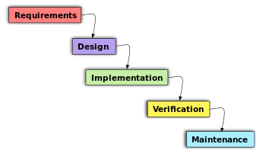

# [CHAPTE](https://1.bp.blogspot.com/-dODuK8N5h1Q/Wlnyb3V9HFI/AAAAAAAACL4/WxQtCJ1pM5wccDABg4wIrTBUB0vlikXQQCLcBGAs/s1600/poly1.jpg)R 7 IMPLEMENTATION

1. **IMPLEMENTATION**

Implementation is the stage where the theoretical design is turned into a working system. The most crucial stage in achieving a new successful system and in giving confidence on the new system for the users that it will work efficiently and effectively.

The system can be implemented only after thorough testing is done and if it is found to work according to the specification. It involves careful planning, investigation of the current system and it constraints on implementation, design of methods to achieve the change over and an evaluation of change over methods a part from planning.

Two major tasks of preparing the implementation are education and training of the users and testing of the system. The more complex the system being implemented, the more involved will be the system analysis and design effort required just for implementation.

The implementation phase comprises of several activities. The required hardware and software acquisition is carried out. The system may require some software to be developed. For this, programs are written and tested. The user then changes over to his new fully tested system and the old system is discontinued.

## TESTING

The testing phase is an important part of software development. It is the Information zed system will help in automate process of finding errors and missing operations and also a complete verification to determine whether the objectives are met and the user requirements are satisfied. Software testing is carried out in three steps:

1. The first includes unit testing, where in each module is tested to provide its correctness, validity and also determine any missing operations and to verify whether the objectives have been met. Errors are noted down and corrected immediately.
2. Unit testing is the important and major part of the project. So errors are rectified easily in particular module and program clarity is increased. In this project entire system is divided into several modules and is developed individually. So unit testing is conducted to individual modules.
3. The second step includes Integration testing. It need not be the case, the software whose modules when run individually and showing perfect results, will also show perfect results when run as a whole.

# [CHAPTE](https://1.bp.blogspot.com/-dODuK8N5h1Q/Wlnyb3V9HFI/AAAAAAAACL4/WxQtCJ1pM5wccDABg4wIrTBUB0vlikXQQCLcBGAs/s1600/poly1.jpg)R 8 SNAPSHOTS

* 1. **SNAPSHOTS**

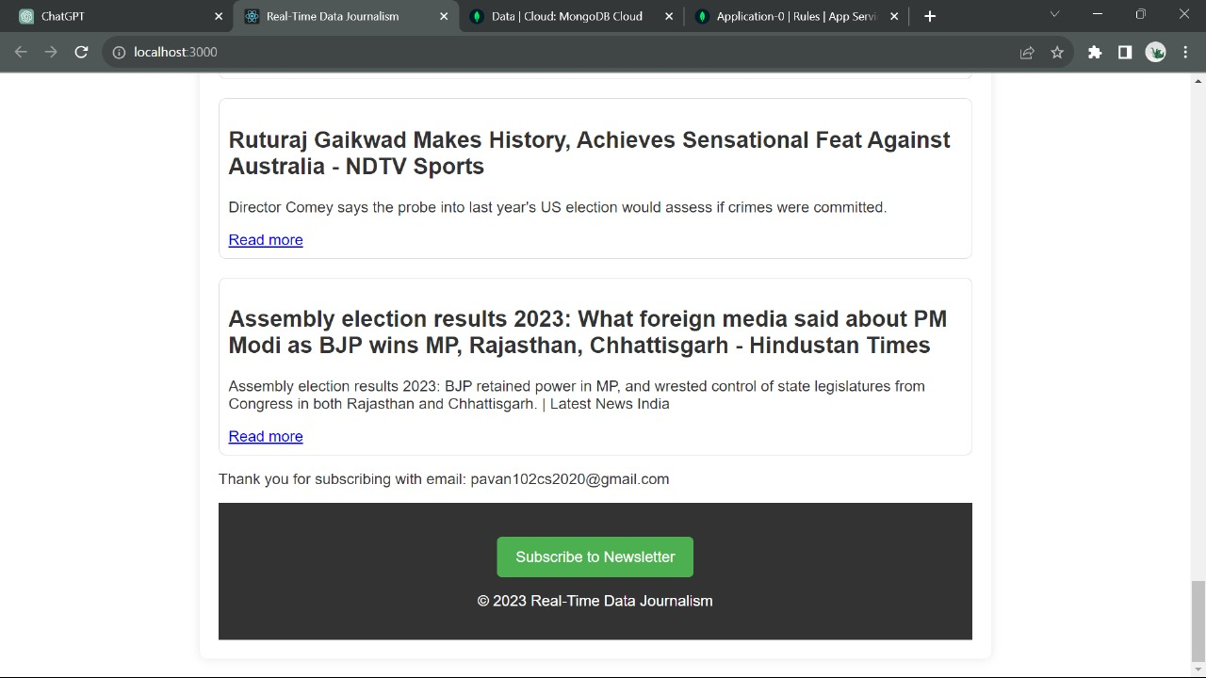

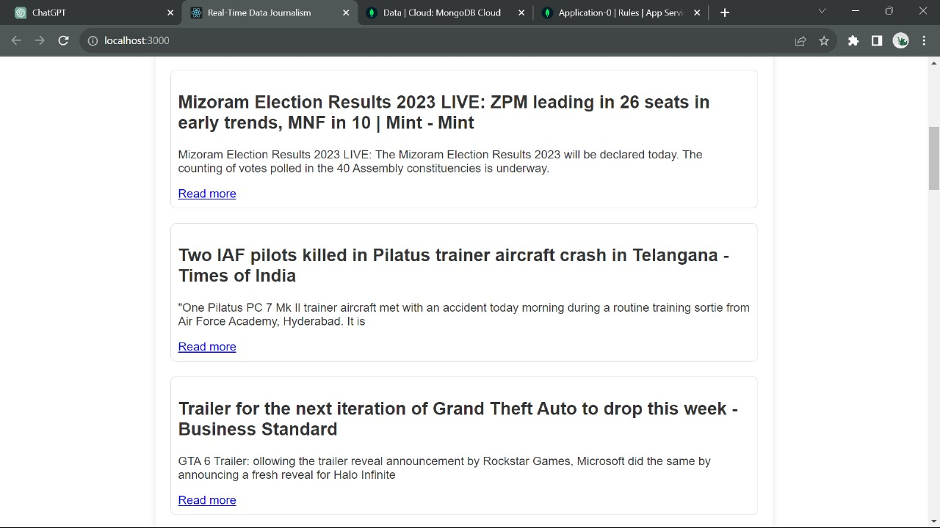

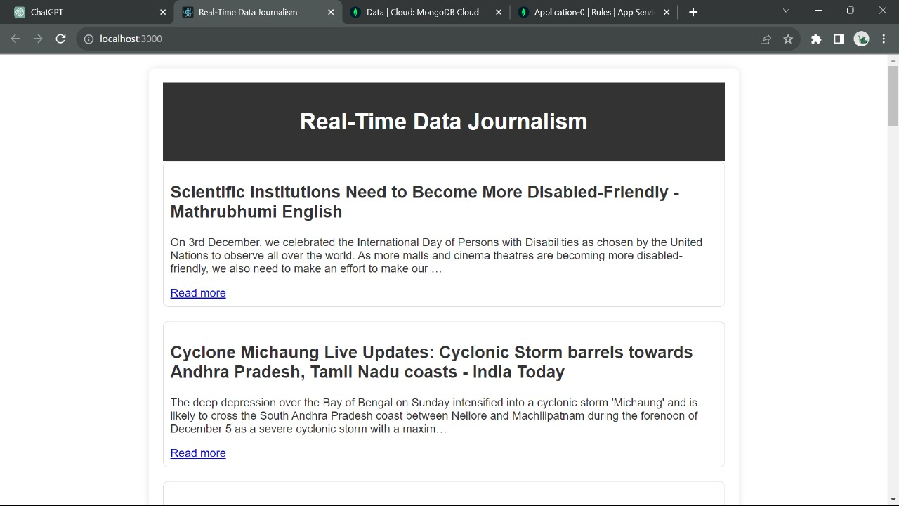

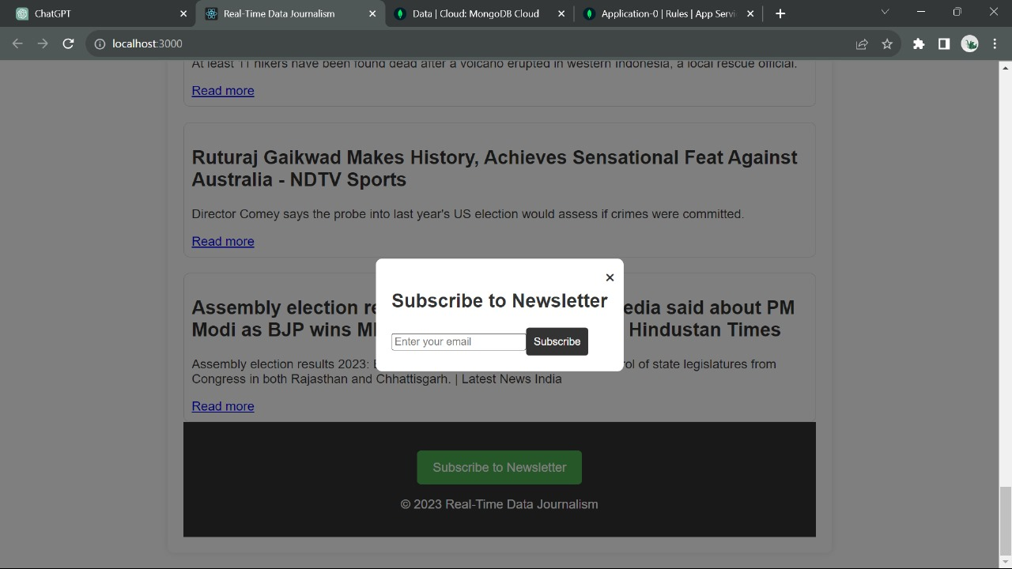

# [CHAPTE](https://1.bp.blogspot.com/-dODuK8N5h1Q/Wlnyb3V9HFI/AAAAAAAACL4/WxQtCJ1pM5wccDABg4wIrTBUB0vlikXQQCLcBGAs/s1600/poly1.jpg)R 9 CONCLUTION

* 1. **CONCLUTION**

The package was designed in such a way that future modifications can be done easily. The following conclusions can be deduced from the development of the project:

* Automation of the entire system improves the efficiency
* It provides a friendly graphical user interface which proves to be better when compared to the existing system.
* It gives appropriate access to the authorized users depending on their permissions.
* It effectively overcomes the delay in communications.
* Updating of information becomes so easier
* System security, data security and reliability are the striking features.
* The System has adequate scope for modification in future if it is necessary.

# REFERENCE

[1]. YouTube: https://[www.youtube.com/](http://www.youtube.com/)

[2].https://youtu.be/qz0aGYrrlhU?si=x7O6A_mAhB-d5J6W

[3]. https://github.com/

[4]. https://[www.gitbook.com/book/google-developer-training/android-developer-](http://www.gitbook.com/book/google-developer-training/android-developer-)

[5]. fundamentals-course- concepts/details